Unit 6: Economics and World Trade
(Lessons 5-6)
Why Do Countries Trade?

Globalization is the worldwide movement toward economic, financial, trade, and communication integration. Improvements in communication and transportation have strengthened international ties and fostered a more global world. In addition, the existence of global problems that affect many countries has motivated those countries to work together to find solutions. One other factor that has greatly influenced this movement toward globalization is global trade, the exchange of goods or services between individuals, organizations, or governments of different nations. International trade is a complex system that has transformed and grown over time.
History of Trade
Trade has been taking place for thousands of years. When people began to settle larger village in the ancient civilizations of Mesopotamia and Egypt, the idea of trying to produce and supply your family’s every want and need began to fade. Farmers began to trade grain for meat or a chicken for a pot at the market. This was the beginning of specialization.
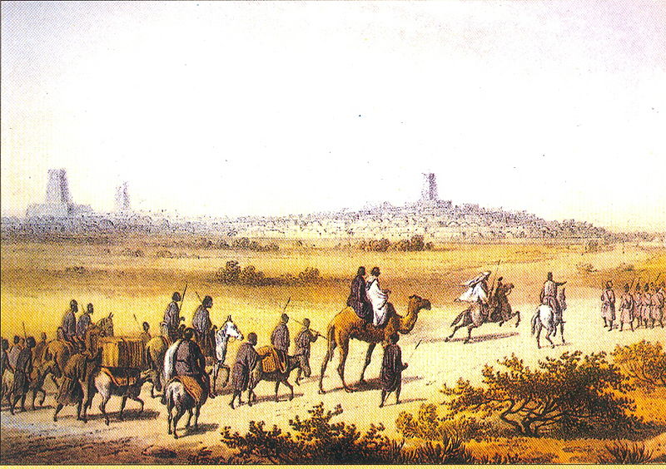
Berber Trade with Timbuktu, 1300’s
https://en.wikipedia.org/wiki/Trade#/media/File:Berber_Trade_with_Timbuktu_1300s.jpg

People from different villages started to trade for similar reasons. They could obtain goods they didn't have from other places far away, where the climate and natural resources provided different products. Long-distance trade in these early times was limited almost exclusively to luxury goods like spices, textiles and precious metals.

Countries trade because it benefits both parties involved. No country has the resources or capability to satisfy all its needs and wants alone. Not only does trade benefit both partners, but having more trading partners increases the variety and amount of trading items available.

Changes in Trade
Although the reasons countries trade have remained much the same, trade itself has greatly changed over time.

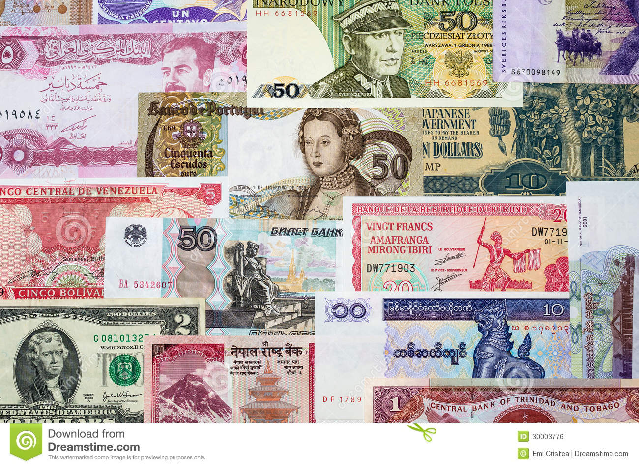
One major change is the use of money or currency as a medium of exchange. Today, most countries have their own currency. The exception is in Europe where almost 20 countries all use the same currency, the Euro. The use of currency has greatly affected global trade because trading with money is much easier and simpler. Before currency, people had to barter for what they wanted. In bartering, people trade goods for goods. Bartering sometimes required several exchanges to ultimately get what you wanted.

The creation of currency made trading easier. However, not all countries’ currencies are of the same value. The difference in the value of various currencies adds to the complexity of international trade. In order to make international trade easier, exchange rates are used. An exchange rate is the amount of domestic currency compared to an equivalent amount of foreign currency. For instance, if one U.S. dollar is equal to $1.30 in Canadian money, the exchange rate is 1.30. Exchange rates allow people to measure and equate the currencies of different countries and enable countries to purchase goods from one another. To look up exchange rates around the world, use the following link: http://www.oanda.com/currency/converter/

In addition to the use of currency, global trade has transformed in many other ways over time. First of all, advancements in communication and travel mean that products and services can be traded much more quickly than in the past. Trades that at one time took weeks or even months to complete, may only take hours or days today. In addition, the volume of goods traded worldwide has sharply climbed as the world’s population has increased along with the demand for more goods. Another dramatic change in world trade is the expansion of the world marketplace. This means that people can get goods from places much farther away than in the past. The growth of global trade routes is illustrated below.
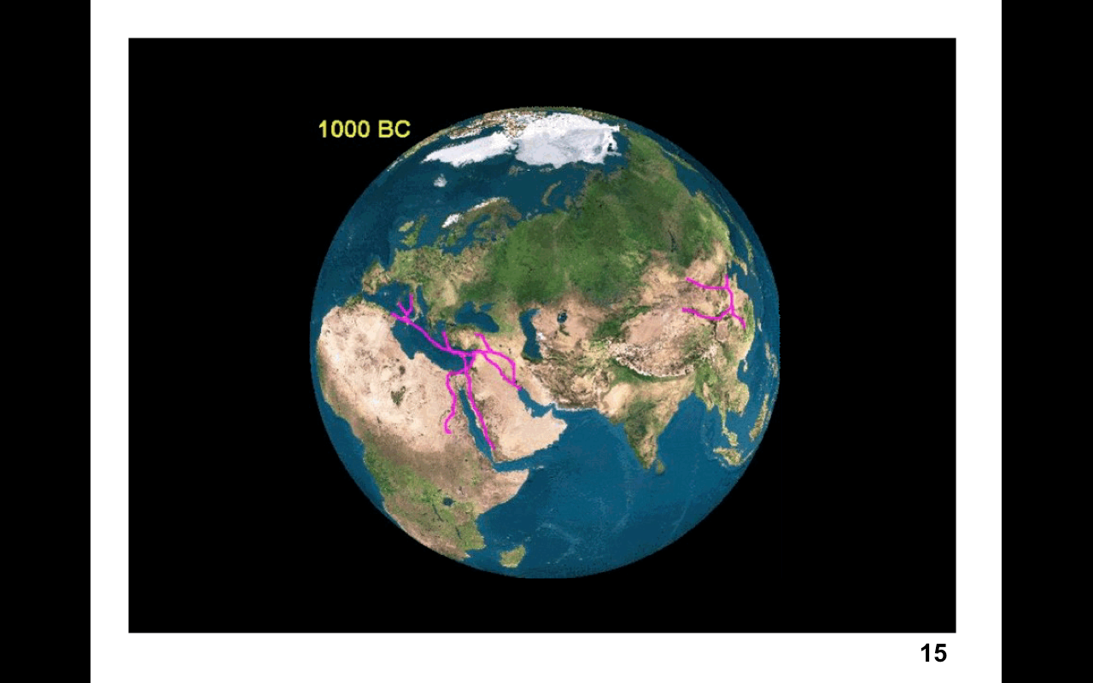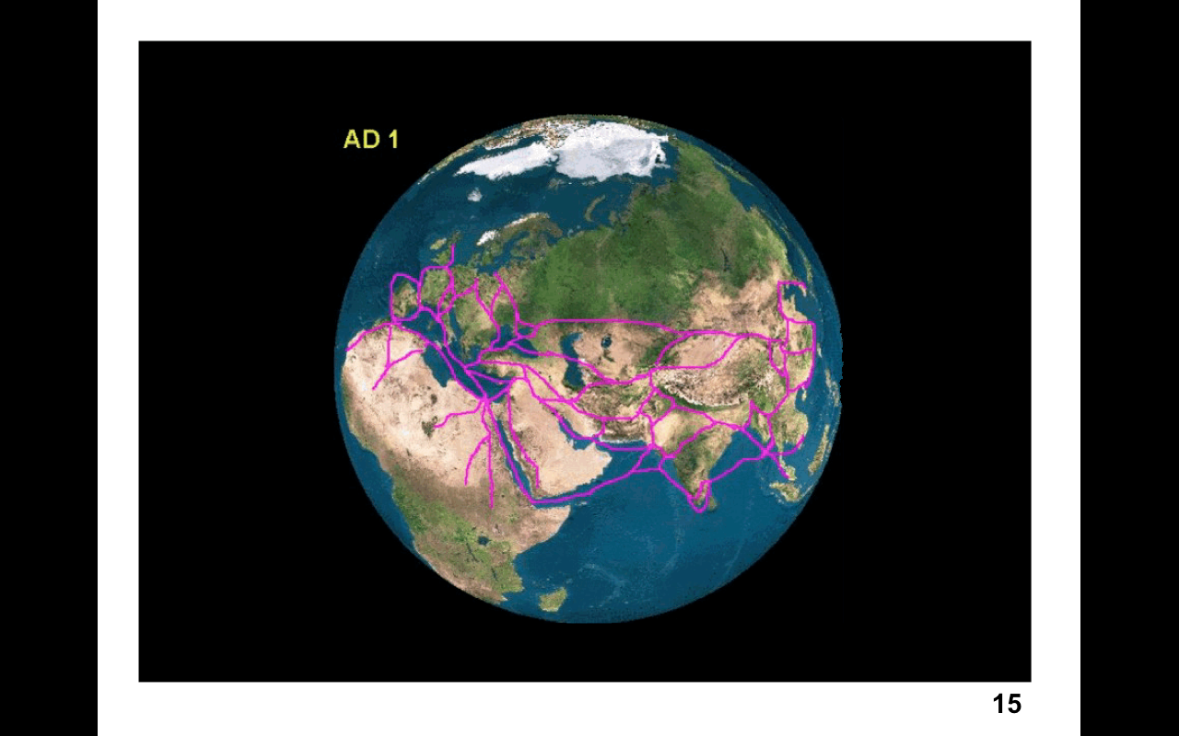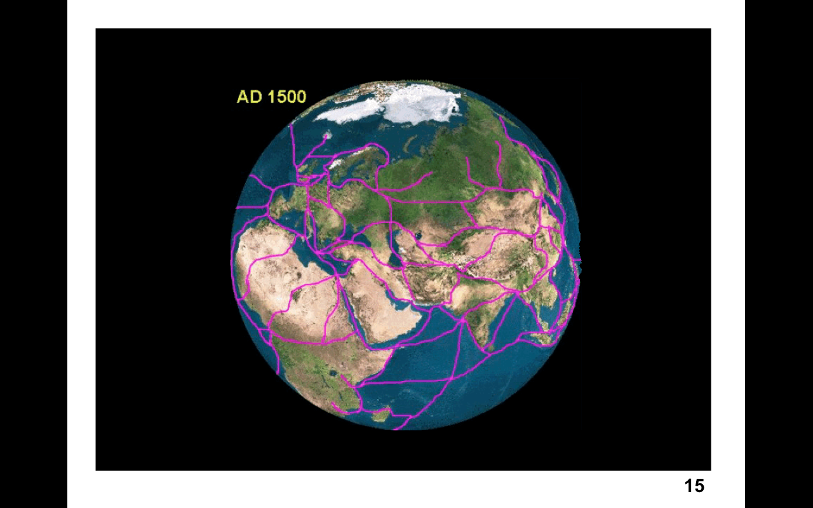
http://www.archatlas.org/Trade/Trade.php?Reload=Reload

The type of goods available for sale is also much more diverse than in the past. In the United States, raspberries, jeans, bicycles, and even cars are imported every day. Lastly, trade has become much more complex in the past century. Many products are just assembled in a particular country, but their parts come from many different places. For instance, most Levi’s jeans are made outside of the United States today.

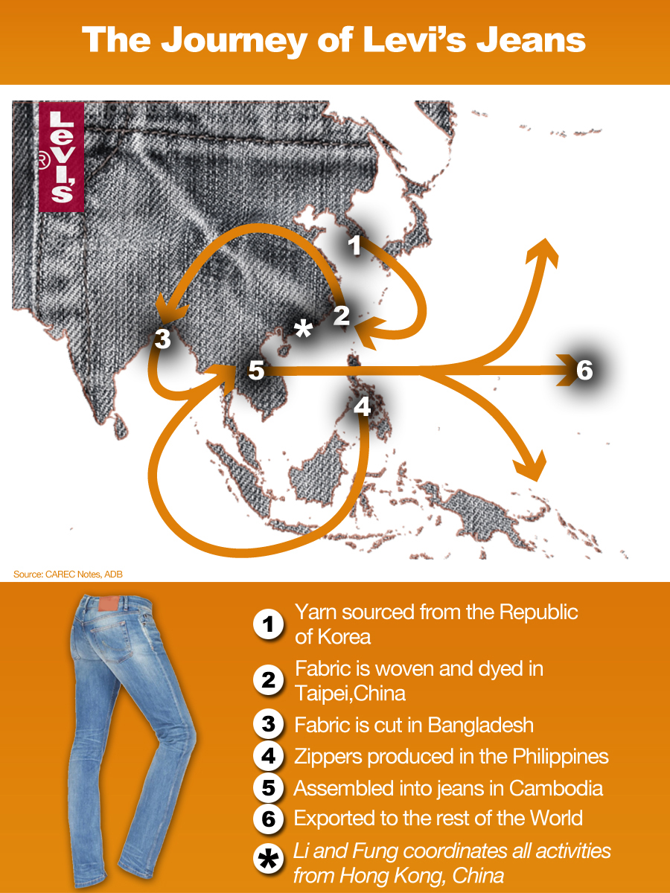The diagram on the right shows the journey of producing a pair of Levi’s jeans. First, yarn is sourced from the Republic of Korea. It is sent to Taipei, China where it is woven and dyed and sent to Bangladesh to be cut. Necessary zippers are all made in the Philippines. Finally, the finished jeans are assembled in Cambodia and exported all over the world. As trade networks have expanded and developed, cultures around the world have been linked like never before.
http://aienetwork.org/infographic/12/from-fiber-to-fashion-unzipping-the-apparel-global-value-chain

Causes of Changes in Global Trade
All of the changes in global trade can be attributed to improvements in communication and transportation. With the availability of cheaper and faster communication and declining shipping costs, even small businesses have access to overseas markets.

Communication - It is easy to take for granted the ease with which we are able to communicate in the world today. However, it has really been the last fifty years that have been revolutionary in terms of communication development and cost. To illustrate:
An Early Minicomputer
https://en.wikipedia.org/wiki/Minicomputer#/media/File:Pdp-11-40.jpg
- Today’s smartphone has three million times the capacity of the first commercially successful minicomputer developed in 1965.
- In 1965, the first commercial communications satellite was launched from the United States. As of 2014, there were about 400 commercial communication satellites processing and transmitting information across the world.
- In 1980, there were five mobile phone subscriptions for every million people; in 2014, there were more than 90 for every 100 people.
- The Internet was introduced to the public in 1991 and started a new era in communication.

All in all, advances in computers and mobile technologies along with a tremendous increase in Internet access has brought people, businesses, and countries closer, while mobile communication has become cheaper and more accessible.

Transportation - The transportation sector has also gone through a major change over the past 50 years. Today, we can travel and ship goods much faster and more cheaply than a half century ago. An airline ticket today may have cost three or four times as much 50 years ago when adjusted for inflation.

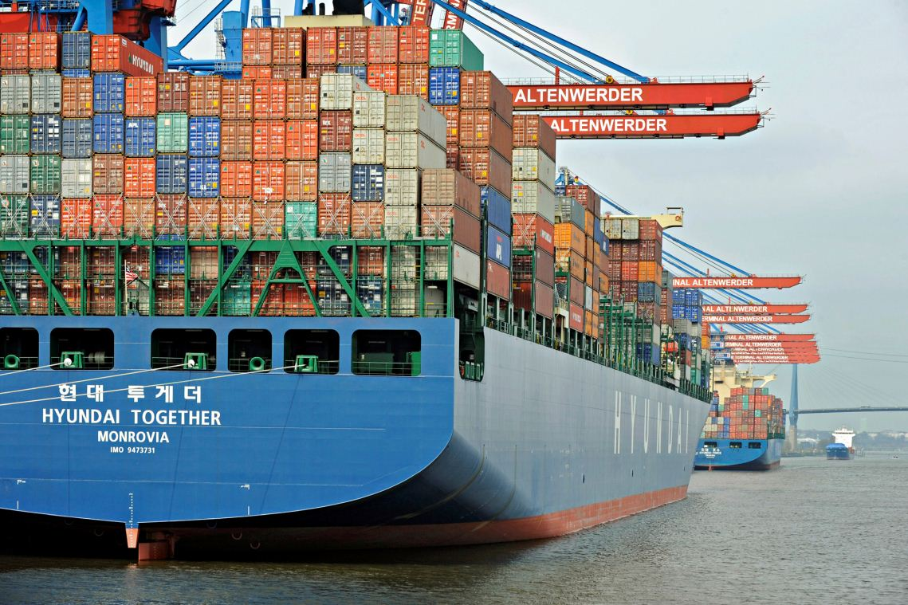
To demonstrate improvement in transportation, consider a container ship as seen in the photo on the right. Each of the containers on a ship is referred to as a TEU (twenty-foot equivalent unit). In the 1950’s, the average container ship carried a maximum of 800 containers. Today a container ship can carry 18,000 containers. It isn’t difficult to see that these much larger container ships allow for greater world trade.

Specialization Leads to Exports and Imports
Countries tend to specialize in the production of goods. This means that they focus on the production of a limited scope of products in order to gain greater degrees of efficiency. It makes good business sense for countries to produce more of what they are efficient at making because the price and quality will appeal to buyers, and there is more money to be made by the seller. This, of course, will lead to the export of the specialized product. When other countries are better at producing a good more efficiently, it makes sense to import those goods rather than make them. Specialization and trade make the countries of the world interdependent.

Countries like the United States have large populations with consumers who are willing to purchase a lot of goods. Why does a country like the U.S. export some goods instead of keep them all in the country? First of all, if there are more goods being produced than a country needs, exporting the excess makes sense. Sometimes goods can even be sold to other countries at higher prices than if they were sold domestically. In this case, it makes good business sense to sell where businesses will make larger profits. Another incentive to export could be a favorable exchange rate. In this case, goods can be sold in order to earn foreign currency that can then be used to purchase imports. Finally, countries that export goods are more likely to employ more of its workers.

Despite the fact that trade can affect things like jobs, the United States and other countries of the world continue to import goods. Sometimes countries import because they want goods that are essential or highly desired but not available in the domestic market. Other times countries import because they want goods that can be produced cheaper or more efficiently by another country.

The United States
Trade Data for 2013
Data are goods only, in billions of dollars
Rank | Country | Exports | Imports | Total Trade | Percent of Total Trade
1 | Canada | 300.3 | 332.1 | 632.4 | 16.4%
2 | China | 122.0 | 440.4 | 562.4 | 14.6%
3 | Mexico | 226.2 | 280.5 | 506.6 | 13.2%
4 | Japan | 65.1 | 138.5 | 203.7 | 5.3%
5 | Germany | 47.4 | 114.6 | 162.1 | 4.2%
6 | Korea, South | 41.6 | 62.2 | 103.8 | 2.7%
7 | United Kingdom | 47.4 | 52.6 | 100.0 | 2.6%
8 | France | 32.0 | 45.3 | 77.3 | 2.0%
9 | Brazil | 44.1 | 27.6 | 71.7 | 1.9%
10 | Saudi Arabia | 19.0 | 51.8 | 70.8 | 1.8%
http://www.census.gov/foreign-trade/statistics/highlights/top/top1312yr.html
The United States benefits from trading with many different countries. Like all countries, we trade with some countries more than others. Examine the chart on the right; it provides data regarding trade between the U.S. and its top ten trading partners. Based on this data, more than 44% of U.S. trade comes from trade with Canada, China, and Mexico combined. Perhaps it isn't a surprise that these three countries are so important to the U.S. given the close proximity of both Mexico and Canada, and China’s ability to mass produce inexpensive goods. Remember, a country is always striving for a favorable balance of trade; this means having more exports than imports. Notice on the chart that the United States only has a favorable balance of trade with one country on the list -- Brazil. The U.S. appears to have the most unfavorable balance of trade with China, which may make the U.S. overly dependent upon China.

Look at the cartogram below that reflects the export of a particular product. It shows that the U.S. exports a great deal of this product, whereas countries in Africa export very little. The exported item is cereal, which includes wheat, rice, barley, and corn.
Cereal is just one of hundreds of products exported from our country each year. Other major exports include civilian aircraft, engines, equipment, and parts; fuel oil; petroleum products; and new and used passenger cars.

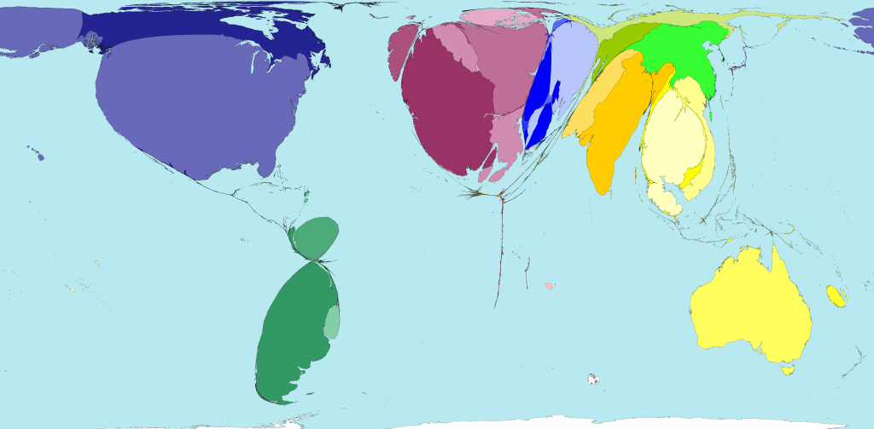
http://worldmapper.org/images/largepng/47.png

Study the cartogram below. It shows the import of a particular good. Notice that the United States, Japan, and countries in Europe import a great deal of this item, while countries in Africa and South America import very little. The item reflected in this cartogram is clothing. The U.S. is certainly capable of making clothes, yet we choose to import them instead. This is primarily because clothing can be produced cheaper elsewhere.
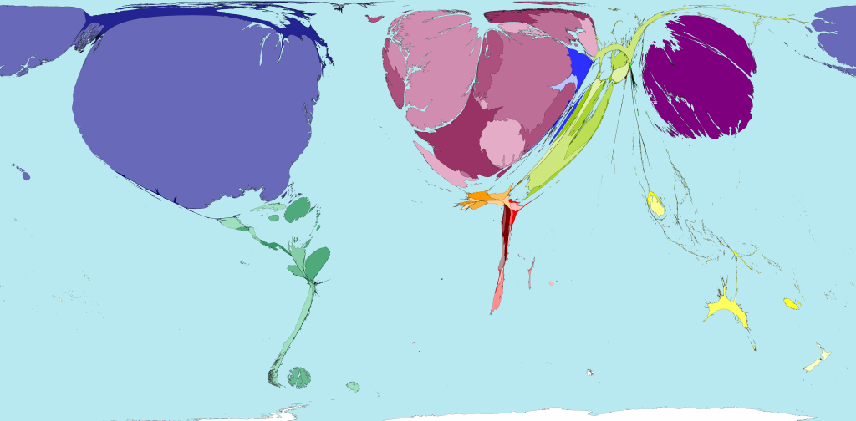
http://worldmapper.org/images/largepng/84.png

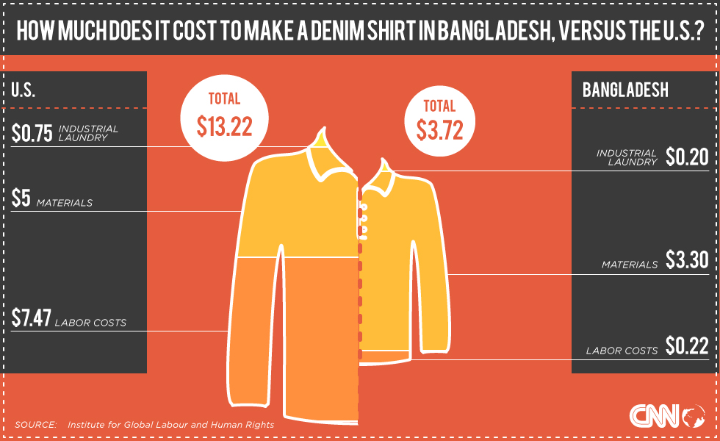
The graphic on the right shows the cost of making the same shirt in the United States and Bangladesh. Wages in Bangladesh are quite low. The lower labor costs in Bangladesh appear to be the biggest reason it is cheaper to make a shirt in Bangladesh. If the U.S. decided to stop importing clothes and instead increased the manufacturing of clothing, what do you think is likely to happen to the price of clothing?
http://www.cnn.com/2013/05/02/world/asia/bangladesh-us-tshirt/index.html?sr=sharebar_google>.

Some people in the U.S. believe it’s important to support a “Buy American” campaign in an effort to protect jobs in the United States. What do you think would happen if we stopped trading with other countries and became dependent on only American goods?

Clothing is just one of hundreds of products imported into the United States each year. Other major imports include crude oil, passenger cars and car parts, medicine, and computers.

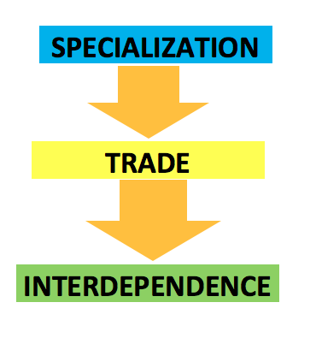

How and Why Do Countries Restrict Trade?

Free trade is the unrestricted trade between nations. This means countries trade without taxes, limits or punishments of any kind. Although free trade has many advantages, some countries restrict trade for a variety of reasons. The four most common restrictions to trade are tariffs, quotas, sanctions, and embargoes.

Tariff
A tariff is simply a tax on imported goods. A tariff of 10% means someone importing a $100 item must pay an additional $10 to the government. The United States has placed tariffs on certain items throughout the years for a variety of reasons. The chart below gives four examples of the use of tariffs in the United States. Notice the reasons behind using tariffs in these instances are quite varied.

PRODUCT | SITUATION | REASON FOR THE RESTRICTION
Tobacco   | Since the Great Depression, the United States has supported farmers. Most forms of support are payments from the government. In a few cases, however, the government has protected farmers with high tariffs or import taxes on products (sugar, dairy products, tobacco). The import rate on certain tobacco products can reach as high as 350%, making it one of the most protected American products around. | To protect American farmers who grow tobacco
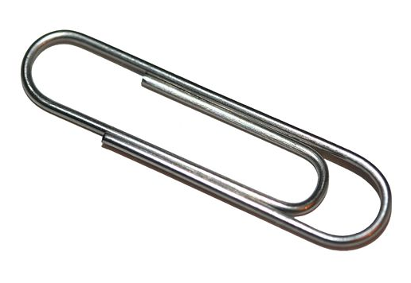  Chinese paper clips | A single paper clip sells for less than a cent. Some 11 billion of them are sold in the U.S. every year. Cheap and nearly disposable, it's hard to imagine that a large majority of domestically sold paper clips are still manufactured in the U.S. For the most part, this is thanks to import taxes reaching as high as 127% on Chinese manufactured paper clips. American companies have benefited from import taxes against China since 1994, when the US government deemed Chinese competition unfair. | To allow American companies to compete with the Chinese companies making paperclips
  French cheese | When the United States invaded Iraq in 2003, France refused to follow. Years later, in its final hours, the Bush Administration reciprocated with a proposed increase in import tax on French Roquefort cheese from 100% to 300%. A tariff three times as high would have seen a pound of the blue-green cheese selling anywhere from $60 to $100 in the United States. This revenge-driven import tax never came to be, and the tariff on Roquefort remained at 100%. | To punish France for not joining the U.S. in invading Iraq in 2003
  Chinese tires | The U.S. placed a tariff on tires made in China. In 2009, a 35% tariff was slapped on tires manufactured in China. By making imported Chinese tires a lot more expensive it was hoped that people would buy more American tires. Policy makers also hoped that this would increase the number of tire manufacturing jobs in the U.S. It didn’t. | To try and increase the number of tire manufacturing jobs in the U.S.

Quota
A quota is a limit placed on the quantity of a product that can be imported. This is a restriction that has been used fairly regularly by the United States, usually in an effort to support U.S. businesses by limiting competition. The automobile industry has, at times, been protected by quotas. In the 1970’s and 1980’s, U.S. automobile manufacturers and labor unions supported government quotas on foreign car imports to limit competition and preserve American jobs.
https://upload.wikimedia.org/wikipedia/commons/8/84/Mercedes-Benz_GLA_200_CDI_Urban_(X_156)_–_Frontansicht_(1),_16._März_2014,_Düsseldorf.jpg

Another example of a product with quotas is the peanut. To help the domestic peanut program of the U.S., an import quota was set all the way back in 1933. Currently the peanut quota is at 7% of U.S. production. This means the amount of peanuts that can be imported cannot be over 7% of the amount of peanuts produced in the United States.
https://commons.wikimedia.org/wiki/File:Cacahuete_-_Petr_Kratochvil.jpg

There are times when tariffs and quotas are used together. To protect U.S. broom companies, the sale of brooms (in addition to mops and feather dusters) is controlled by both a tariff and a quota. These products are subject to an 8% tariff when valued under $0.96. There is also a quota of 121,478 dozen units. For units valued at more than $0.96 each, there is no quota, but the tariff imposed rises to 32%.

Sanction
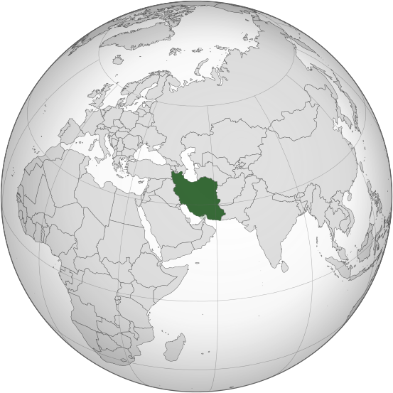
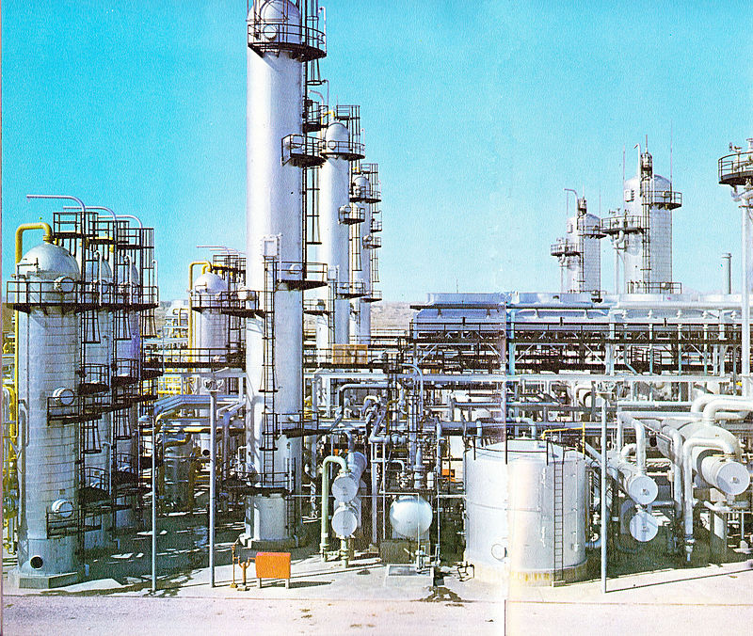
A sanction is a term used for a penalty levied on another country. Sanctions are political trade restrictions put in place against target countries with the aim of maintaining or restoring international peace and security. Their main purpose is usually to change a behavior in a country. Sanctions contain information as to why they have been implemented and specify what their aim is. An example of trade sanctions occurred in 2012 and 2013. Because the United States objected to Iran’s nuclear program, they worked to block the sale of oil from Iran to other countries. These sanctions led to a sharp decline in Iran’s oil exports and two years of negative economic growth.
https://en.wikipedia.org/wiki/National_Iranian_Gas_Company#/media/File:Bidboland_gas_refinery.jpg

In 2015, Iran agreed to an exclusively peaceful nuclear plan going forward. In exchange, the U.S. and a host of other countries agreed to lift international oil and financial sanctions. The removal of these sanctions is expected to boost Iran’s exports and revive its economy.

Embargo
The last type of trade restriction is an embargo. An embargo prevents a country from trading with another. It is similar to a sanction in that it is a tool typically put in place for political reasons. Perhaps the most commonly known U.S. trade embargo is against Cuba. Following the communist revolution in Cuba and later the Cuban Missile Crisis, the United States banned all trade with the island nation and severed all diplomatic ties. Cuba’s economy has been greatly damaged by the half-century old U.S. trade embargo. The presidents of both countries recently announced the countries would restore diplomatic ties. However, the crippling trade embargo against Cuba, which requires congressional approval to be rescinded, is still in place keeping the countries from trading.
https://commons.wikimedia.org/wiki/File:Old_Havana_Cuba.jpg

The Pros and Cons
Trade restrictions can have both positive and negative consequences. On the positive side, trade restrictions can protect domestic industries, save jobs, bring in revenue for a government, and help a country attain a political or social goal. On the negative side, trade restrictions can cause prices to increase for consumers, result in fewer choices of goods, bring about shortages, and invite retaliation in the form of restrictions from other countries.

Working Toward Free Trade
Despite all of the examples of trade restrictions above, countries of the world have been working toward freer trade since the end of World War II. For example, most countries belong to the World Trade Organization (WTO), which oversees global trade. The WTO serves as a forum for multilateral trade negotiation, administers multilateral trade agreements, decides trade disputes, and reviews national trade policies. Countries also sometimes form trade agreements to bring about freer trade.

What might be some of the challenges to getting large numbers of countries to agree on a trade issue? Consider the following:
Suppose your class wants to come to an agreement around the issue of the amount of homework students get. While many students do not like homework, some may see that using time out of school to continue learning is valuable and may help them in the future. For example, a student who reads and studies more than other students may have higher test scores or otherwise be more attractive to competitive colleges, which may open doors in terms of careers, etc. Other students may be involved in many extra-curricular activities, have jobs after school, or responsibilities at home that make it difficult to do homework. Students may have different life and career goals. Students also may have different types of resources available to help with homework, from human resources such as parents to capital equipment to do the homework like computers. Students may also differ in the amount of time they have available. With different goals and different resources available, it may be hard to get the entire class to agree.
The same issues exist with countries in trade – differences in goals and available resources often make it difficult for many countries to join together in one agreement because it may not meet their needs or be in their best interest. It is often easier to find common ground when there are fewer people trying to reach agreement.
Because of these challenges, there tend to be more regional trade agreements than multilateral, or many-nation, trade agreements. Regional trade agreements are between neighboring countries. Regional agreements in existence today include the North American Free Trade Agreement (NAFTA), the European Union (EU), the Andean Trade Preference Act, the Economic Community of West African States, the Greater Arab Free Trade Area, and the South Asia Free Trade Agreement.

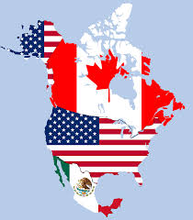NAFTA
https://commons.wikimedia.org/wiki/File:TLC_map.png
NAFTA, North American Free Trade Agreement, is the trade agreement that most likely affects us. This agreement between Canada, Mexico, and the United States promotes unrestricted trade among these countries, creating the world’s largest free trade area.

NAFTA benefits trade because it eliminates tariffs, leading to a decrease in the cost of imports (especially oil and farm goods) and a lower cost to export goods as well. One result of NAFTA was an increase in U.S. farm exports to Mexico. In fact, Mexico is a top export destination for U.S. products including beef, rice, soybeans, soybean meal, corn, corn sweeteners, apples, beans, and oils. Overall, NAFTA has increased trade between these countries, helped small businesses grow, reduced reliance on oil imports from the Middle East due to increased oil imports from Canada and Mexico. The U.S. economy is healthier due to NAFTA.

There have been some negative consequences to NAFTA as well. Since labor is cheaper in Mexico, many manufacturing industries moved part of their production from high-cost U.S. states to Mexico. This resulted in a loss of U.S. jobs. Some companies that stayed in the United States threatened to relocate if workers joined a union. Without union support, wages of American workers were kept low. In Mexico, when tariffs were removed on imported farm products from the United States, rural Mexican farmers could not compete, and many farm jobs were lost. NAFTA also led to an increase in the number of Mexican workers working near the border working long hours without labor rights or health protection. Lastly, the trade agreement resulted in competitive pressure leading Mexican farmers to pollute through the use of more chemicals and deforest land in order to expand into new areas.
People continue to argue for and against free trade. Read the arguments below outlined for each position. Do you think free trade should be the goal or are restrictions of some kind always going to be necessary?

Argument For Free Trade | Argument Against Free Trade
Through global competition, specialization, and access to technology, free trade and openness allow countries to grow faster—India and China started in the 1980s with restrictive trade policies, but as they have liberalized they have also improved their growth enormously. The International Trade Commission estimates that a free trade agreement between just Colombia and the US would increase the US GDP by $2.5 billion. When industries have to compete with competition around the world, they are pushed towards innovation and efficiency. Entrepreneurs are more productive if they have to compete. Free trade increases access to technology which also increases overall development. Because of free trade, prices are lower for everyone. Trade offers benefits to both developed and developing nations by encouraging competition, efficiency, lower prices, and opening up new markets to tap into. | Although free trade may promote innovation and growth, because of issues like dumping (where rich countries sell their products very cheaply in poorer countries and make it impossible for local industry to compete), or jobs being exported to places where labor is cheaper, free trade has significant costs and does not necessarily foster benefits for all. It is necessary to grow infant industries and create jobs, and free trade hurts both.
Source: Arguments For and Against Free Trade. 22 January 2015 <http://idebate.org/es/node/17550>.

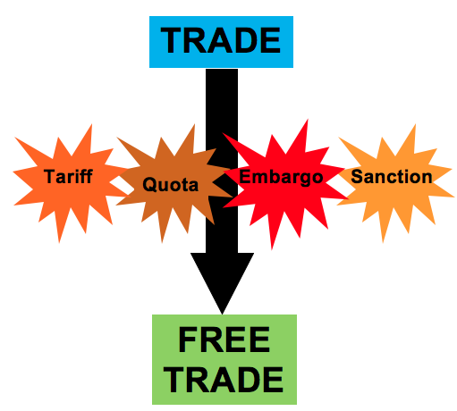

Would you like to experience the challenges and excitement of international trade? The link below will take you to a simulation where you can see if you can get the best price for the goods you sell and the biggest bargains for the goods you buy.

http://www.imf.org/EXTERNAL/NP/EXR/CENTER/STUDENTS/TRADE/index.htm

Make sure to watch at the top of the page how the global economy is doing: the prices you’ll be able to get and the deals you can make depend on how healthy the global economy is.

